When the Going gets tough
Sunday school:
Story: Jesus likes to tell stories to many people. Sometimes he told them to lots of people and other times he told stories to his disciples. One day, Jesus was talking with his disciples. He told them ‘Students are not better than their teacher,’ he said to them. ‘A slave is not better than his master. Instead they need to be like each other.’ He continued, ‘So do not fear. I do not want you to worry. Everything that is hidden will be found and everything that is secret will be discovered. Anything I say to you in the dark, I want you to tell in the light. Anything that is whispered, I want you to shout from the rooftops!’ Jesus reassured them. ‘Do not fear those who try to harm you, as they cannot harm your soul. The only one you should be worried about is the one who can harm both the body and the soul. He told them; Two sparrows are sold for only a penny. But if one of them falls to the ground, God knows this. Even the hairs on your head are counted and known by God. So I tell you, Do not fear, you are much more valuable than the sparrows.’ Jesus said to his disciples, ‘If you tell others that you are my follower, I will tell God in heaven that you are my follower. But if you say you are not my follower, I will have to tell God in heaven that you don’t belong to me. I did not only come to bring peace but also I came to bring a sword. Families may turn against each other because of what I say. You must love God more than even your family to be my follower. And they must be willing to take up their cross to be my follower. If you try to hold onto your life, you will give up true life. But do not fear. If you give up your way life for me, you will hold onto true life.’
Story Link: https://www.youtube.com/watch?v=k673LsGhVxw
Secret Messages: Jesus said :Everything that is hidden will be found and everything that is secret will be discovered. Anything I say to you in the dark, I want you to tell in the light.
What you will need-
White Crayon, Paper, Watercolour Paint, Water, Paintbrushes
How- Use a white crayon to write a secret message on a white sheet of paper. You may draw pictures, notes, letters, numbers, etc. Use the watered down paint to reveal your secret message

Count the small things: 5 mins E S
A reminder that even the little things are important to God
You will need: a clear jar full of small objects, e.g. seeds, sweets, dried peas.
- Ask the children to count how many objects there are in the jar – without taking them out.
- Explain that God even knows how many hairs we each have on our head, not just the number of objects in a jar. This shows just how much God knows each one of us and values us. It’s a reminder when we are finding things hard that God is with us, in the small and big things in life.

Shout it from the roof tops: in the bible reading today Jesus wants us to shout from the roof tops what he has told us, can you use the disciple sheet attached and make a cardboard house. Then put your disciples on the roof top so they can shout Gods word
You will need – a cardboard box, felt tips, masking tape or cellotape, disciple sheet, cardboard template.
Use the template to cut out a cardboard shape to make your house, decorate your house anyway you want
Colour in and cut out you disciples from the disciple sheet

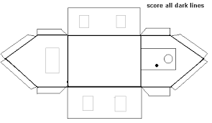

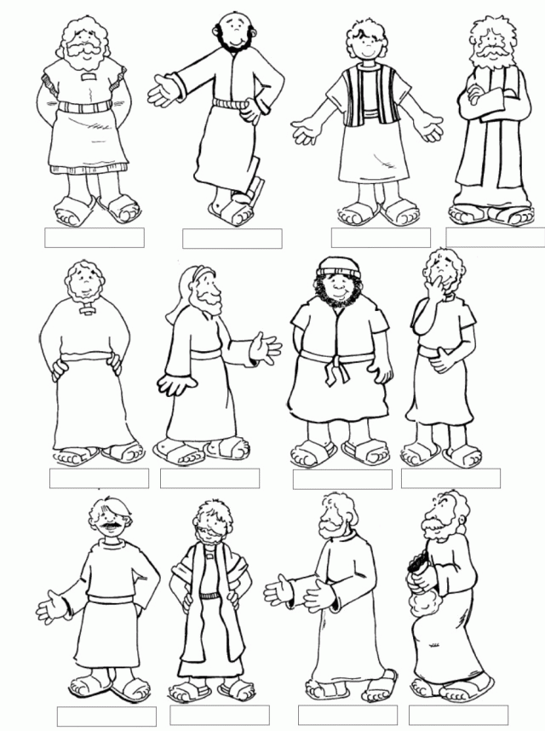
Tug of war: when we have different opinions to our friends and family it can feel very much like playing tug of war. Have a go with your family to find out what this feels like
You will need- a length of rope or skipping rope, a piece of coloured material or old t shirt to tie in the middle, a piece of chalk or a stone to draw a halfway line
How to play: The objective of the game is for each team to pull the rope along with the members of opposition team to their side. As soon as the coloured material on the rope crosses over the centre line, the team to pull the rope to their area wins the game. The tug of war competition requires a judge.

Youth Division:
Discussion Question: Matthew continues Jesus’ teaching on mission to the world. Jesus points out that the disciples must expect some opposition, including possibly from their own families, since Jesus himself has been opposed and called names. He reminds them that God loves and values them as a father. What Values have you learnt and adopted from your family and friends? Which of your values are in conflict with those of your families and friends?

Game: 5 mins E
You will need some ‘mint thin’ chocolates for each young person. Explain that the aim of the challenge is to start off by putting the chocolate on your forehead and then slide it down your face, using only your facial muscles – no hands! The person to get the chocolate into their mouth fastest wins (they can then eat the chocolate!). This may seem easy at first but can actually be quite a challenge! Discuss some of the challenges the young people may have faced this week.

Jumbled instructions 15 mins WE
Print or copy out a set of jumbled recipe instructions (below) can you rearrange them into the correct order. Reminder: sometimes a challenge in our discipleship journey is the distractions life can throw at us, but we can talk to God and ask for guidance to help us. If you have time, follow the correctly ordered instructions to complete the recipe.
Instructions:
Place them in the oven till golden brown 15-25 minutes.
Cool on a wire rack before serving.
Gently sift in 200g of self-raising flour and mix until cake batter is smooth
Preheat the oven to 180 degrees C / gas mark 4.
Pour the mixture into two non-stick 7inch (18cm) tins.
Crack four eggs and add to the butter and sugar mixture carefully
Measure 200g each of sugar and butter into a bowl and whisk until creamy.
Can you now make this recipe?

Don’t put God in last! 10 mins ES

You will need – a large jar, large rocks, gravel or small stones, sand, Water
Your large jar to represent your life. Then put in several rocks until it seems the jar is full: these rocks represent God – God should come first and take up the most room in our lives. Next, add some gravel (until the jar seems full): this represents things such as family, friends, jobs – these take up a lot of time. Next, add some sand: to represent things like TV, social media. These things also fill up our lives and sometimes distract us from God. Finally, add some water (pour until the jar is full) – to represent everything else in our lives. If we were to put the gravel, sand and water in first, we couldn’t fit the rocks in. This is the same with our lives: if we don’t put God first, we get so busy with other things that our call to be disciples becomes difficult.
Music:
Under 5s
The Lord is my rock, Freedom kids
One more step along the world I go
Under 12s
Lean on you, Hillsong kids on Tell the world
Jesus in my life, Hillsong kids on Super strong God
12+
Love won’t let me down, Hillsong young & free on Love won’t let me down
Gotta live, Tedashii on Never fold

